Virtual Campus Tour

COMP 1536 Website Development Project

Simon Wu

Ian Lo

Jacky Li

Akemi Haraguchi

Table of Contents

[MILESTONE 2 5](#_Toc473735448)

[PROJECT SITE MAP 5](#_Toc473735449)

[COLOR SCHEME 6](#_Toc473735450)

[PAGE LAYOUT 7](#_Toc473735451)

[HOME 7](#_Toc473735452)

[BUILDINGS INFO 7](#_Toc473735453)

[BUILDINGS 7](#_Toc473735454)

[CONTACT 7](#_Toc473735455)

[GLOSSARY 7](#_Toc473735456)

[USER LOGIN 8](#_Toc473735457)

[USER ADMINISTRATION 8](#_Toc473735458)

[USER REGISTRATION 8](#_Toc473735459)

[APPENDIX 1: MILESTONE 1 9](#_Toc473735460)

[PROJECT SUMMARY 9](#_Toc473735461)

[MISSION 9](#_Toc473735462)

[GOAL/OBJECTIVE 9](#_Toc473735463)

[COMPARASION WITH SIMILAR SITES 9](#_Toc473735464)

[PROJECT SUMMARY 10](#_Toc473735465)

[MEASURING SUCCESS 10](#_Toc473735466)

[FUNCTIONAL REQUIREMENTS 12](#_Toc473735467)

[THE LOG-IN FEATURE 12](#_Toc473735468)

[USER AUTHENTICATION 12](#_Toc473735469)

[SERVER SIDE PROCESSING 12](#_Toc473735470)

[OTHER FEATURES 12](#_Toc473735471)

[PROJECT EXECUTION PLAN 13](#_Toc473735472)

[SCHEDULE 13](#_Toc473735473)

[PLAN 13](#_Toc473735474)

[ROLES 14](#_Toc473735475)

[DEADLINES 14](#_Toc473735476)

[ADDENDUM 14](#_Toc473735477)

# MILESTONE 2

## PROJECT SITE MAP

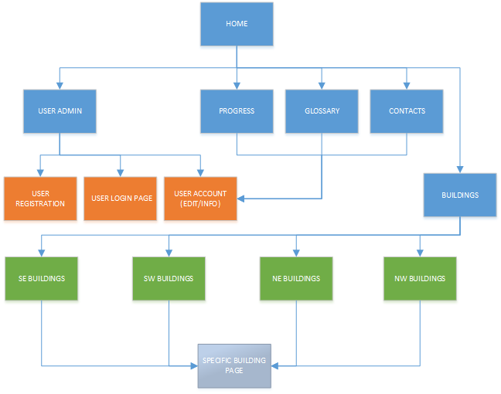

Figure 1 - Project Site Map

## COLOR SCHEME

The color scheme for this website will be similar to BCIT’s site just to be consistent.

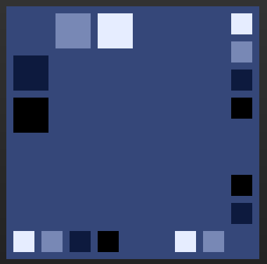

Figure 2 - Color Palette for Site

[Click here for the color palette link.](http://paletton.com/" \l "uid=13N0u0kk8my3y++c8zssob-F900)

If not all of these colors have enough contrast between them, countermeasures such as an 80% opacity white background behind the text will be utilized where needed.

|  |  |
| --- | --- |
| C:\Users\Jacky\AppData\Local\Microsoft\Windows\INetCache\Content.Word\Website_Layout_Coloured.png  Figure 3 - Sample Color Scheme for FrontPage | As seen on the left, not all colors from the palette will be utilized, further elucidation in future versions will be available.  Contrasting colors will also be used for outstanding content, if need be. |

## PAGE LAYOUT

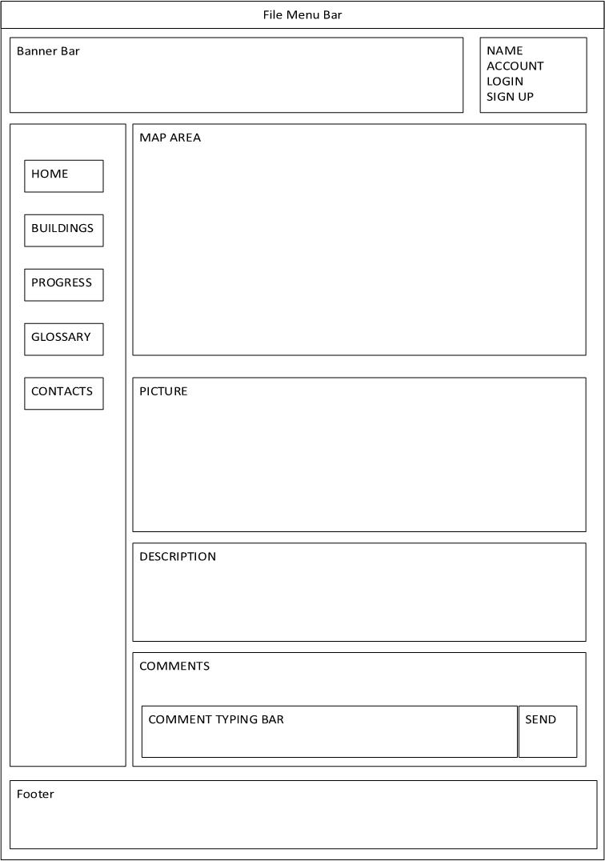**HOME**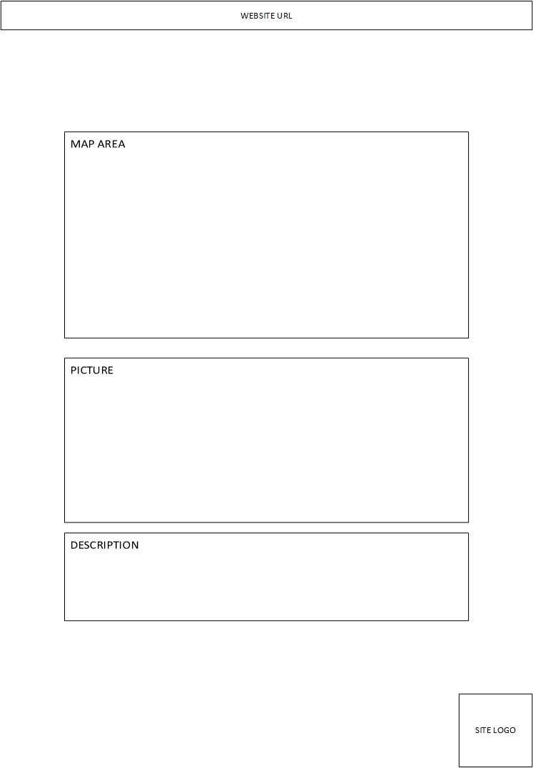HOME (PRINT PAGE)

Figure 4 - The homepage will show the interactive BCIT map.

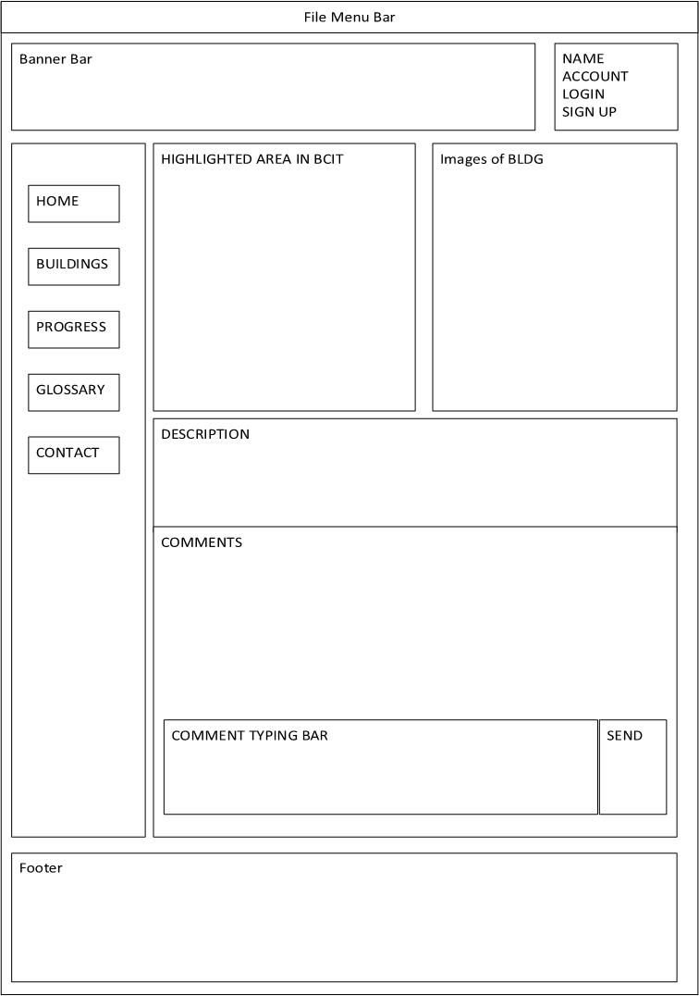**BUILDINGS INFO**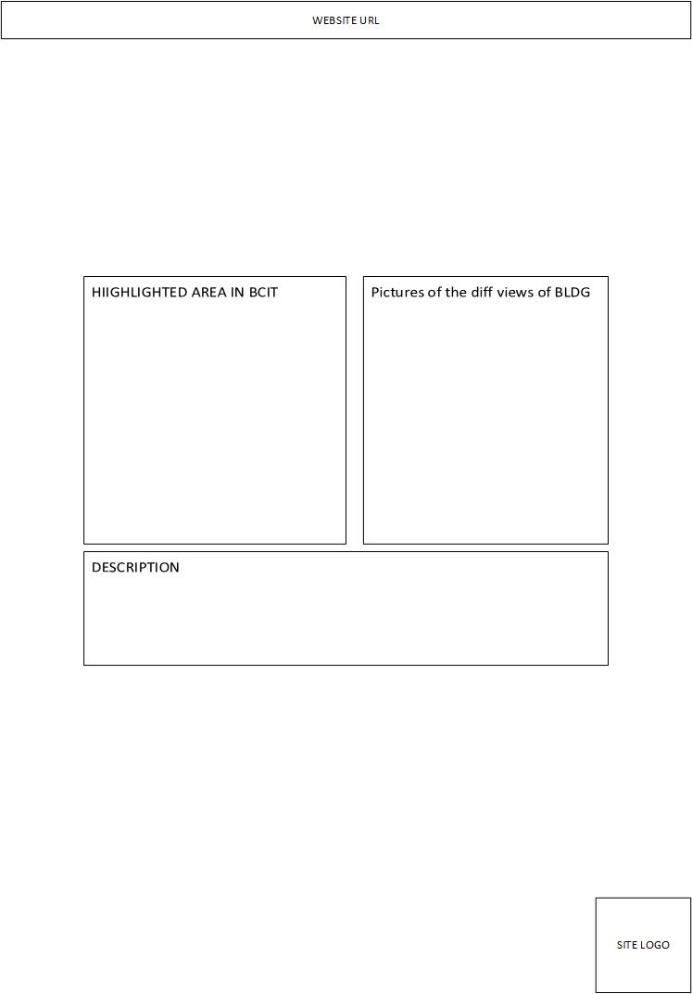BUILDINGS INFO (PRINT PAGE)

Figure 5- This page is available once the user selects the desired building.

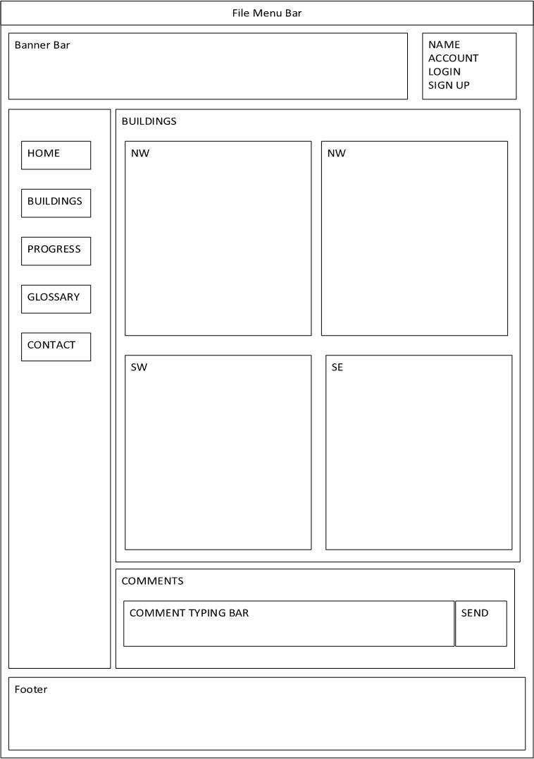**BUILDINGS**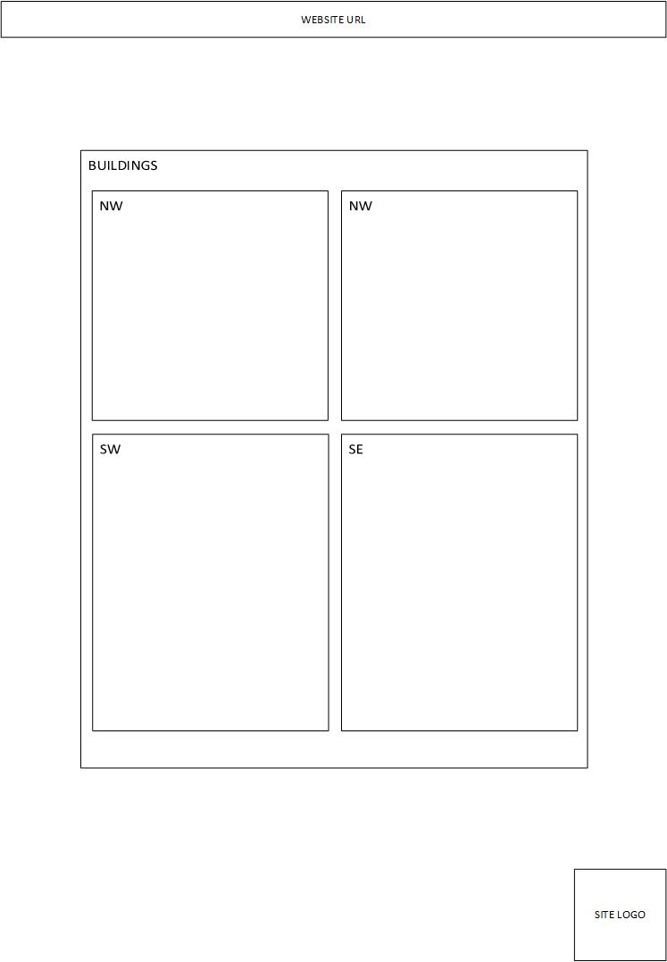BUILDINGS (PRINT\_PAGE)

Figure 6 - This is an option for users who may want to search by building rather than where they are.

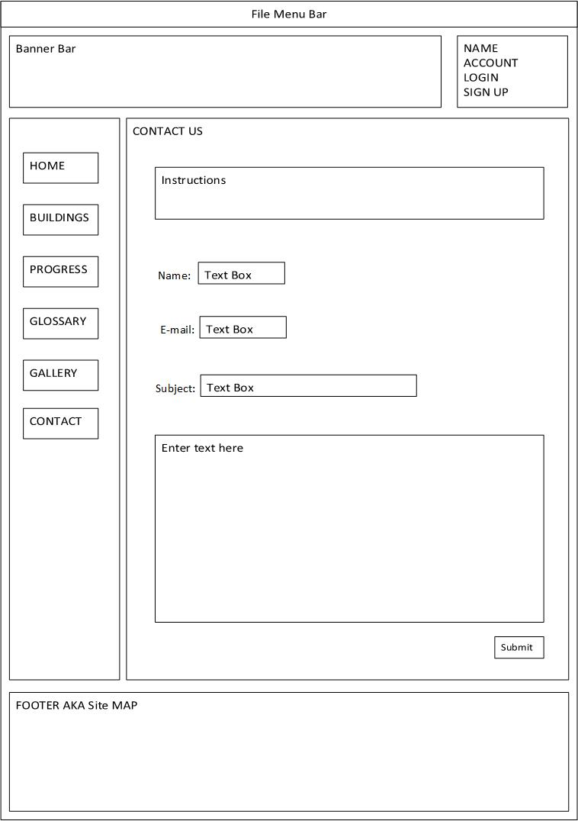**CONTACT**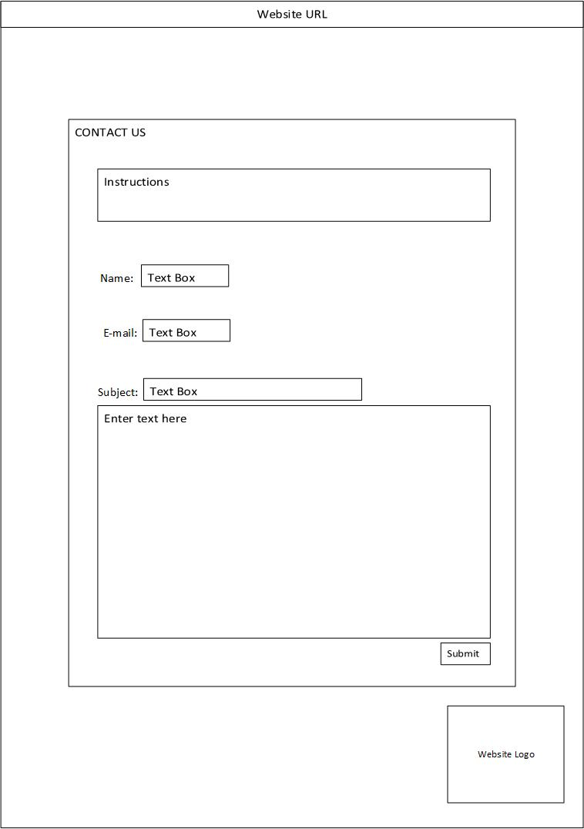CONTACT (PRINT PAGE)

Figure 7 - Users may contact the developers directly from this page.

### **GLOSSARY**GLOSSARY (PRINT PAGE)

Figure 8 - Glossary, equipped with a comments section so suggestions can be given out by users.

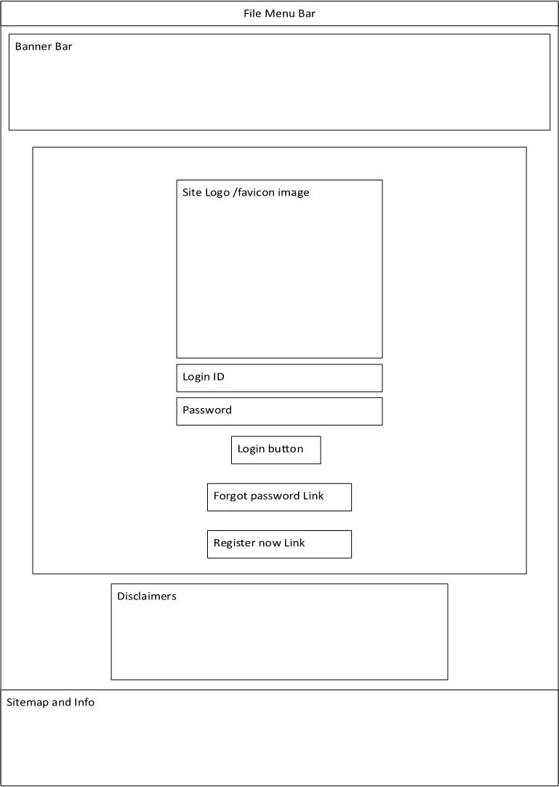**USER LOGIN**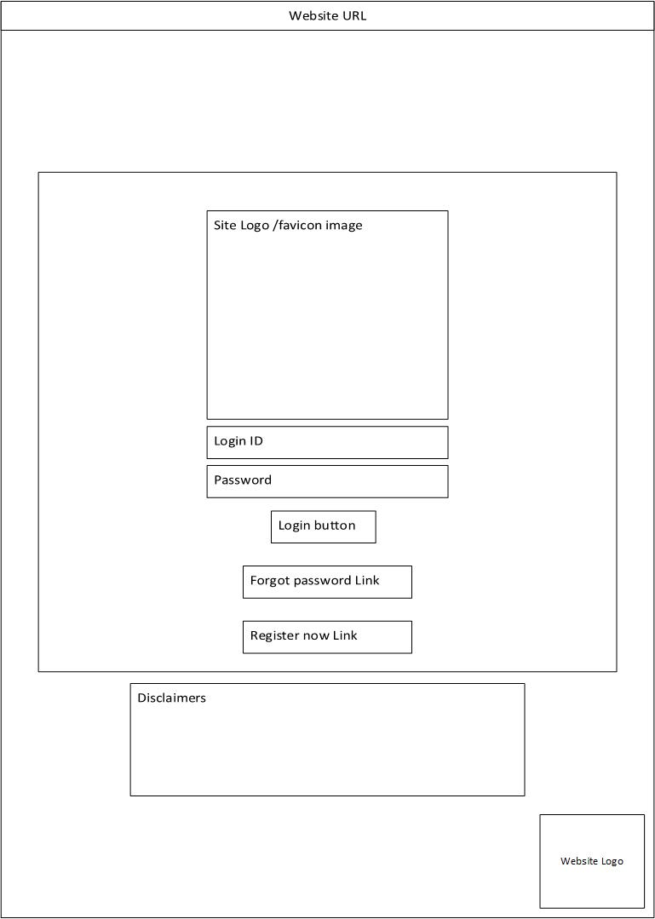USER LOG-IN (PRINT PAGE)

Figure 9 - The user log-in page can be accessed from the top right-hand corner.

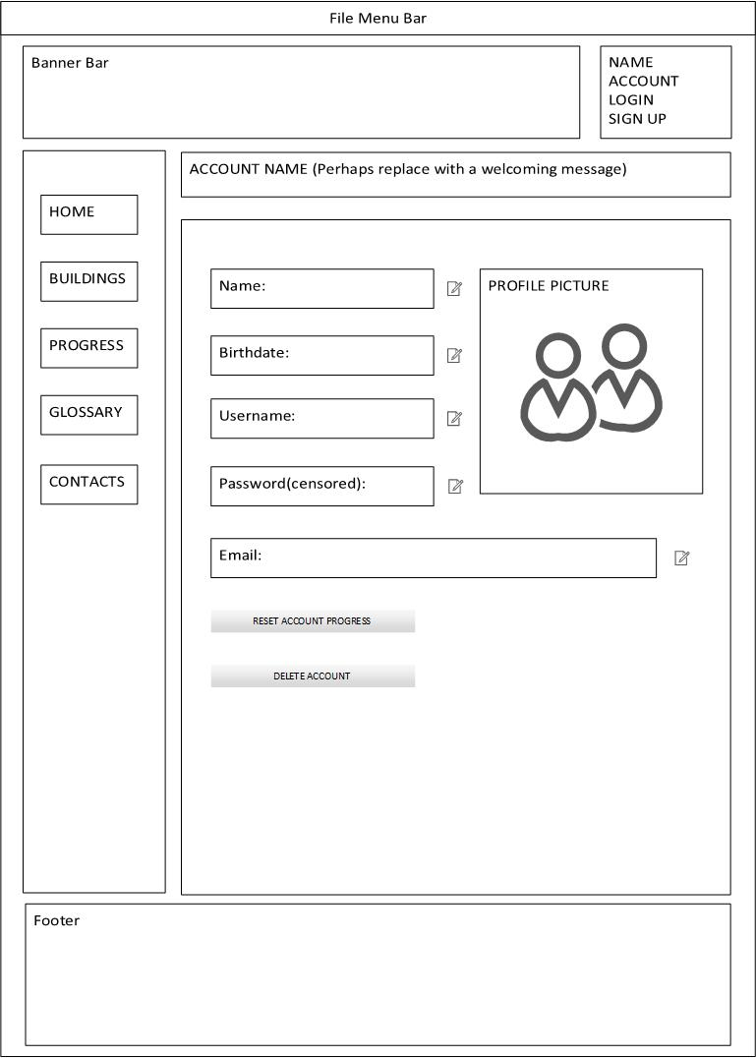**USER ADMINISTRATION**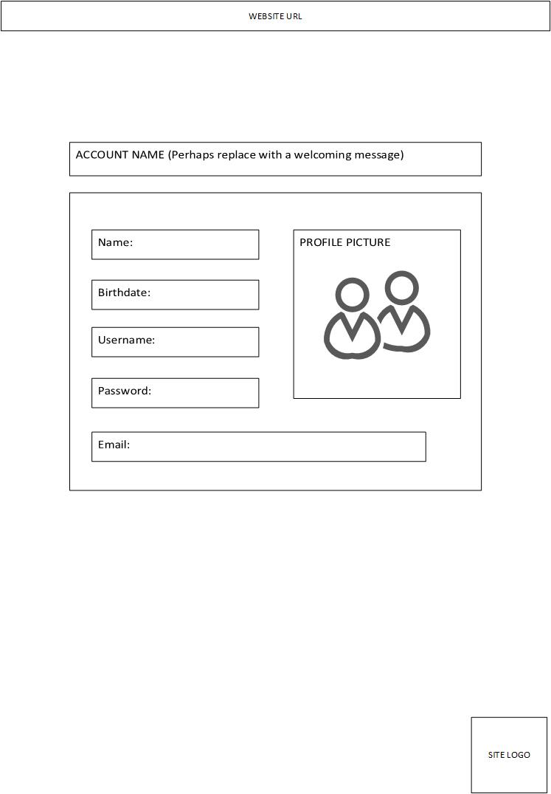USER ADMINISTRATION (PRINT PAGE)

Figure 10 - Users will be able to change their personal information on this page.

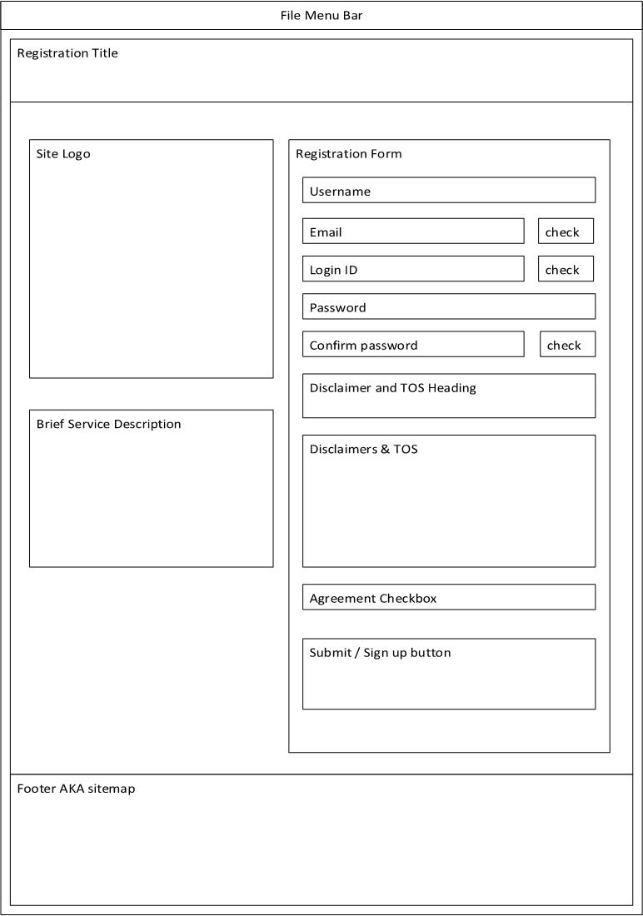**USER REGISTRATION**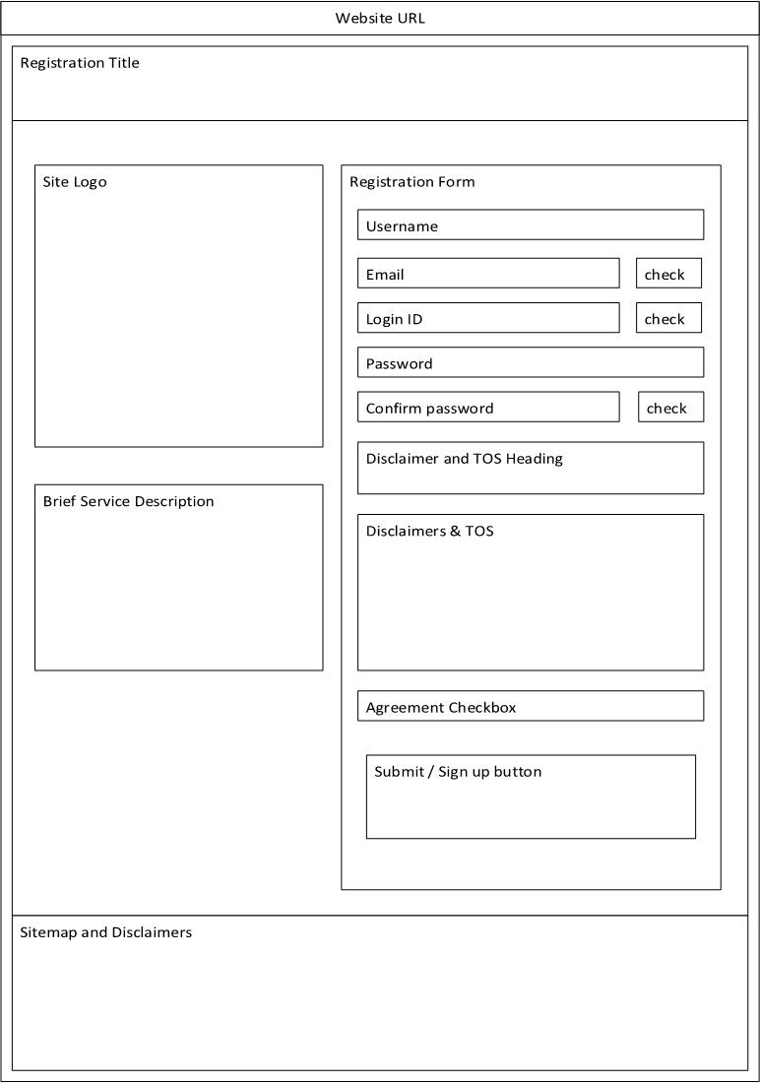USER REGISTRATION (PRINT PAGE)

Figure 11- User registration will be free-of-charge, and should ask for minimal information.

# APPENDIX 1: MILESTONE 1

## PROJECT SUMMARY

### **MISSION**

There are currently no readily accessible BCIT maps for new students; the Campus Tour given to students on the welcoming day does not fully cover the entire campus.

Every student coming into BCIT for the first time can agree that navigating the campus can be an arduous task. The campus tour provided by the student volunteers at our program orientation was somewhat underwhelming and hard to follow—the BCIT campus is simply too complicated to be able to learn in a single tour. While there are maps located throughout the campus—and even an interactive one in SW1 (as well as a map in the Safety Wise app)—they are either glitchy or non-portable.

Our mission is to create an interactive, portable, and intuitive map that can help visitors and new students alike to better navigate the hallways of BCIT, and make finding their destinations easier.

## 

### **GOAL/OBJECTIVE**

The purpose of the website is to:

1. Provide a clean and interactive map for new students and visitors so that they can better navigate the BCIT campus.
2. Motivate students and visitors to explore different areas of BCIT Burnaby campus

This site will make students actively search out relevant school property and to get them used to the campus as soon as possible, via a “quest” system. School sites that have already been visited will be highlighted on the website to reflect that effect.

### **COMPARASION WITH SIMILAR SITES**

Since our website works with “waypoints” and GPS locations to confirm if the user has reached a waypoint, it works similarly like the recent PokemonGO game’s Pokestops; where the user, when within range of a waypoint, can receive in-game items and perks. In constructing our website, we take our inspirations from the two examples below:

#### BCIT MAP

*Source:* <http://www.bcit.ca/map/>

The BCIT map website is very comprehensive and contains a lot of information and locations of where each building is situated. However, while the BCIT map is rather comprehensive, it can also be overwhelming and confusing to navigate—especially for a new student or visitor. Our website addresses this issue by removing most of the map and having our users slowly unlock each section by physically exploring the campus.

#### UBC MAP

*Source:* <http://www.maps.ubc.ca/PROD/index.php>

The UBC map website is less interactive compared to the BCIT map website due to the map being only a picture. However, this also provides the benefit of a faster loading time, as the website does not need to connect to Google Satellite. We plan to use pictures for our website maps as well to reduce loading time.

### **PROJECT SUMMARY**

The campus map website will provide an intuitive map to help students locate their buildings faster while giving quick notes on the general area. The site will have an image of the campus map with linked objects for each building. The site will also provide a GPS location service scan to show where the user is on the map. The website will function like an interactive quest game, where the user can unlock different sections of the map once he or she has physically visited the place. Below the map area will be a picture of what the particular building/place looks like followed by the description section and comments section where the user can input notes and comments. Figure 1 below is a rough draft of how the mobile website should look like.

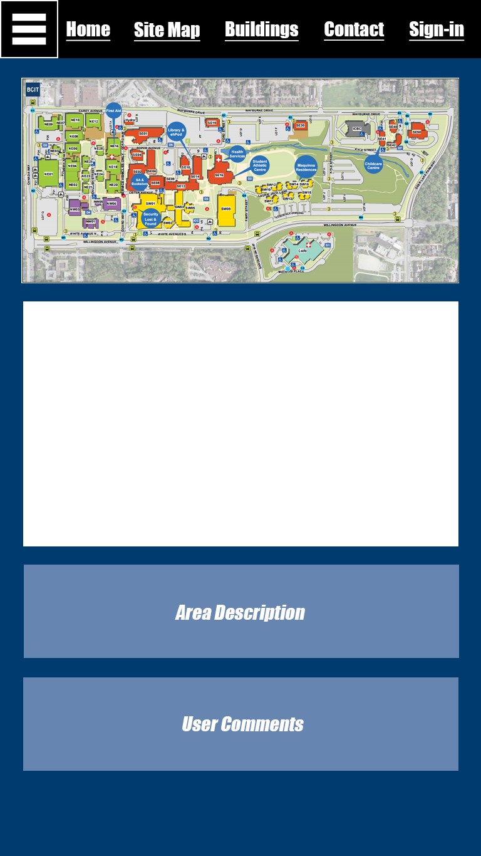

Figure : Initial Concept of the Website

### **MEASURING SUCCESS**

We plan to gauge the success of our website by the reviews and ratings from our users. We will have a review section on our webpage that allows the users to rate our website out of 5 and leave optional comments. This will also allow us to continue to improve our website based on user feedback. We may encourage users to rate and review by providing extra perks such as unlocking a map section.

## FUNCTIONAL REQUIREMENTS

### **THE LOG-IN FEATURE**

Those who want to interact and keep track of where they have been will be required to make a login username and password. This ensures that if a student wants to save their progress, they will be able to save that information to their User ID.

Those registered also have the option of leaving comments on places that they’ve been to. This allows the students to collaborate and help improve the map for future visitors and students.

### **USER AUTHENTICATION**

Once the user logs in, their name will be displayed on the top right corner of the webpage. Clicking on the name will display their user profile, which includes their login name, email, password (censored), and map unlock progress. There will be an edit button beside the password field if the user wishes to change the password.

## 

### **SERVER SIDE PROCESSING**

There will be a database on the server where the user’s login information is stored. The database will also store the user’s map “quest” progress.

## 

### **OTHER FEATURES**

### 

#### Feedback Box

There will be a comment section on each page where users can post suggestions.

#### List

We will have a page with a glossary of terms on the different names and jargons at BCIT. For example, the word “ehPod” would be a term listed under our glossary with the associated definition/explanation beside it.

#### Contact Us

There will be an option for users to contact us in the case of any problems, issues, or bugs. This will most likely be in form of a message box that the users can fill out and submit through the website.

## PROJECT EXECUTION PLAN

## 

### **SCHEDULE**

**Week 1**

Project proposal, rough layout of work plan, segment responsibilities

**Week 2**

Website scaffolding, plan on graphics - custom if need be

Back-end development talks

**Week 3**

Complete basic layout of the website and colors selection

Start work on establishing user database and logistics.

**Week 4 + Week 5 + Week 6**

Code. Development phase

**Week 7 + Week 8 + Week 9**

Start of week 7: Review current progress

Week 8 + 9: Damage control if need be, continue coding.

**Week 10**

Final testing and verifications

**Week 11 + Week 12 + Week 13**

Float time.

## 

### **PLAN**

In order to make this website a success, communication and cooperation between team members is crucial. Our plan is to start early and try to work in pairs as much as possible. Depending on the size of the task and the capability of the team members, resource/task delegation and pairings may change.

### **ROLES**

Each member in the group has an assigned role.

1. Simon Wu: Project Leader
2. Ian Lo: Head Coder
3. Jacky Li: Document Control
4. Akemi Haraguchi: Website Aesthetics Designer

### **DEADLINES**

Members will meet every Wednesday after-class. Members are expected to arrive on time and be prepared for the meeting. We will attempt to schedule items ahead of time with individual due dates to ensure the overall project milestones are delivered on time. Following the first milestone, a project Gantt chart will be constructed in-order to better delegate resources and tasks. The project schedule will be updated on a weekly basis to reflect actual progresses.

### **ADDENDUM**

Regarding the difficult of our project objectives and scope, we suggest the following plan:

1. The core requirements of the project will be addressed first:
   1. Basic website interface
   2. Navigation menu
   3. Requirements listed on the project document
2. The GPS tracking function will be allotted low priority and attempted only if time allows
   1. As a result, the user “quest progress” function will only be implemented when all other core functions are complete and running smoothly.